|  |  |
| --- | --- |
| **Ex. No. 10** | **Angular JS Application Building** |
| **Date of Exercise** | 10-OCT-2022 |
| **Web Host Link** | <https://github.com/Manudhas9385/Experiemnt-10> |

**Aim:**

To create web pages using AngularJS Directives.

**Description:**

**Ng-route:** If you want to navigate to different pages in your application, but you also want the application to be a SPA (Single Page Application), with no page reloading, you can use the ngRoute module. The ngRoute module routes your application to different pages without reloading the entire application.

**Form Validation:**AngularJS offers client-side form validation. AngularJS monitors the state of the form and input fields (input, textarea, select), and lets you notify the user about the current state.AngularJS also holds information about whether they have been touched, or modified, or not.You can use standard HTML5 attributes to validate input, or you can make your own validation functions.

**Program:**

**(a)Create Christmas Megaplay 2022 registration form and perform validation using angular JS.**

<!DOCTYPE html>

<html>

    <head>

        <script src="https://code.angularjs.org/1.6.9/angular.js"></script>

        <script>

            var app = angular.module('registration',[])

            app.controller('regcontroller', function($scope)

            {

            });

        </script>

        <style>

        body {

            background-image: url('background.jpg');

          }

        div.a{

            font-size: large;

            color: yellow;

        }

          </style>

    </head>

    <body ng-app="registration" style="color: blue;">

        <form  ng-controller="regcontroller" name="regform">

            <br>

            <br><br><br><br><br><br>

            <br>

            <br>

            <h1>Christmas Megaplay 2022 Registration Form</h1>

           <div class="a">

            <table style="align-items:center ;">

                <tr>

                    <td style="width:35%"><label for="name">Name : </label><span style="color: red">*</span></td>

                    <td><input type="text" ng-model="name" id="name" name="name" required pattern="[a-z,A-Z]{1,}">

                    <span style="color: red" ng-show="regform.name.$error.required">Name is required</span>

                    <span style="color: red;" ng-show="regform.name.$error.pattern">Name is invalid</span></td>

                </tr>

                <tr>

                    <td><br></td>

                    <td><br></td>

                </tr>

                <tr>

                    <td><label for="register" >Register Number:</label><span style="color: red">*</span></td>

                    <td><input type="text" ng-model="register" id="register" name="register" required>

                        <span style="color: red" ng-show="regform.register.$error.required">Register Number is required</span>

                       </td>

                </tr>

                <tr>

                    <td><br></td>

                    <td><br></td>

                </tr>

                <tr>

                    <td><label for="register" class="box">Year of Study:</label><span style="color: red">*</span></td>

                    <td><input type='radio' name="year" ng-model="year" value="1st" required>1st

                        <input type='radio' name="year" ng-model="year" value="2nd" required>2nd

                        <input type='radio' name="year" ng-model="year" value="3rd" required>3rd

                        <input type='radio' name="year" ng-model="year" value="4th" required>4th

                        <span style="color: red;"ng-show="regform.year.$error.required"> Year is required</span>

                        </td>

                </tr>

                <tr>

                    <td><br></td>

                    <td><br></td>

                </tr>

                <tr>

                    <td><label for="age">Age : </label><span style="color: red">*</span></td>

                    <td><input type="number" ng-model="age" id="age" name="age" required min="18" max="30">

                        <span style="color: red" ng-show="regform.age.$error.required">Age is required</span>

                        <span style="color: red;" ng-show="regform.age.$error.min">Age is invalid</span>

                        <span style="color: red;" ng-show="regform.age.$error.max">Age is invalid</span></td>

                </tr>

                <tr>

                    <td><br></td>

                    <td><br></td>

                </tr>

                <tr>

                    <td><label for="number">Mobile Number : </label><span style="color: red">*</span></td>

                    <td><input type="number" ng-model="number" id="number" name="number" required pattern="[0-9]{10}">

                        <span style="color: red" ng-show="regform.number.$error.required">Number is required</span>

                        <span style="color: red;" ng-show="regform.number.$error.pattern">Mobile number is invalid</span></td>

                </tr>

                <tr>

                    <td><br></td>

                    <td><br></td>

                </tr>

                <tr>

                    <td><label for="email">Email : </label><span style="color: red">*</span></td>

                    <td><input type="email" ng-model="email" id="email" name="email" required>

                        <span style="color: red" ng-show="regform.email.$error.required">Email is required</span>

                        <span style="color: red" ng-show="regform.email.$error.email">Email Format</span></td>

                </tr>

                <tr>

                    <td><br></td>

                    <td><br></td>

                </tr>

                <tr>

                    <td><label for="gender">Gender :</label><span style="color: red">*</span></td>

                    <td><input type="radio" ng-model = 'gender' name="gender" value="male" id="gender" required>Male

                        <input type="radio" ng-model = 'gender' name="gender" value="female" id="gender" required>Female

                        <span style="color: red" ng-show="regform.gender.$error.required">Gender is required</span></td>

                </tr>

                <tr>

                    <td><br></td>

                    <td><br></td>

                </tr>

                <tr>

                    <td><label for="activity">Activity:</label><span style="color: red">*</span></td>

                    <td><select ng-model="activity" id="activity" name="activity" required>

                        <option value="song">Song</option>

                        <option value="dance">Dance</option>

                        <option value="drama">Drama</option>

                        <option value="mime">Mime</option>

                        <span style="color: red" ng-show="regform.activity.$error.required">Activity is required</span></td>

                </tr>

                <tr>

                    <td><br></td>

                    <td><br></td>

                </tr>

                <tr>

                    <td></td>

                    <td><input type="submit" ng-disabled=" regform.name.$error.required || regform.password.$error.required || regform.age.$error.required ||

                         regform.number.$error.required || regform.email.$error.required || regform.gender.$error.required || regform.state.$error.required" ></td>

                </tr>

            </table>

        </div>

        </form>

    </body>

</html>

**Output:**

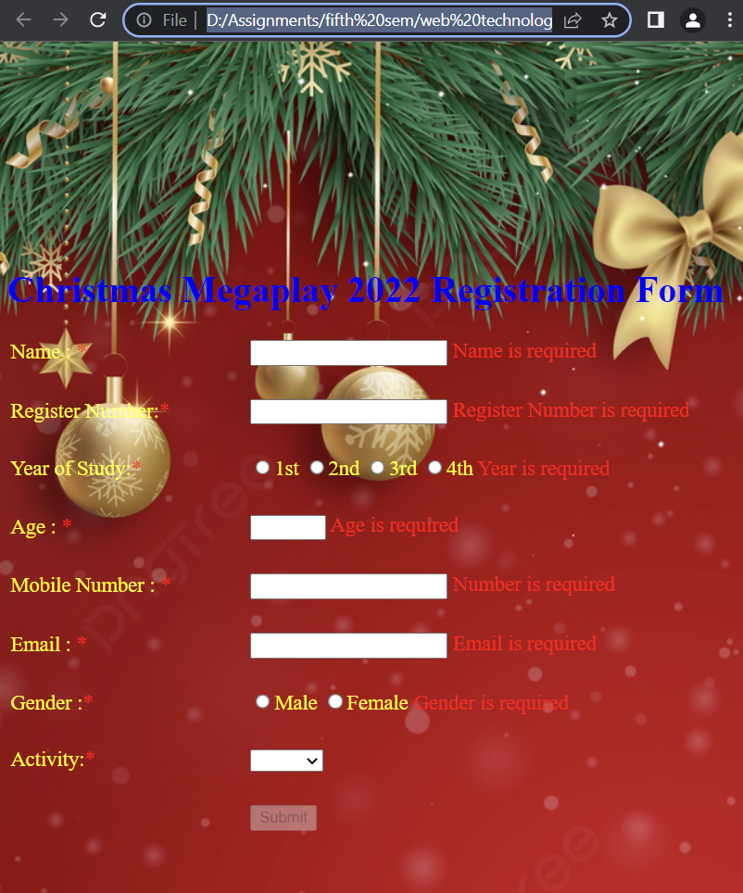

**(b)Create a webpage to perform show multiple regno and display the profile of the on clicking the regno selected using Routing concept in Angular Js**

<!DOCTYPE html>

<html lang="en">

    <head>

        <meta charset="UTF-8">

        <meta http-equiv="X-UA-Compatible" content="IE=edge">

        <meta name="viewport" content="width=device-width, initial-scale=1.0">

        <script src="https://ajax.googleapis.com/ajax/libs/angularjs/1.6.9/angular.min.js"></script>

        <script src="https://ajax.googleapis.com/ajax/libs/angularjs/1.6.9/angular-route.js"></script>

        <script>

            var app=angular.module("myApp",['ngRoute']);

            app.config(function($routeProvider){

               $routeProvider.when('/2028',{

                templateUrl:'2028.html'

               })

               .when('/2048',{

                templateUrl:'2048.html'

               })

               .when('/2052',{

                templateUrl:'2052.html'

               })

               .when('/2047',{

                templateUrl:'2047.html'

               })

            });

        </script>

    </head>

    <body ng-app="myApp">

        <divclass="sidebar"width="20%">

            <h2>REGISTER NUMBERS</h2>

            <a href="2028.html"><b>URK20CS2028</b></a>

            <a href="2048.html"><b>URK20CS2048</b></a>

            <a href="2052.html"><b>URK20CS2052</b></a>

            <a href="2047.html"><b>URK20CS2047</b></a>

        </div>

        <div class="content" ng-view></div>

</body>

</html>

**2050.html:**

<html>

<body>

    <h2></h2>

<br><br>

<P>

    <b>Register Number: </b>URK20CS2050

    <br>

    <b>Course: </b>BTech Computer Science and Engineering (Specialization in Artificial Intelligence)

    <br>

    <b>Year of Duration: </b>2020 - 2024

</P>

</body>

</html>

**2048.html**

<html>

<body>

    <h2>Arun</h2>

<br><br>

<P>

    <b>Register Number: </b>URK20CS2048

    <br>

    <b>Course: </b>BTech Computer Science and Engineering (Specialization in Artificial Intelligence)

    <br>

    <b>Year of Duration: </b>2020 - 2024

</P>

</body>

</html>

**2052.html**

<html>

<body>

    <h2>Giftson Raja</h2>

<br><br>

<P>

    <b>Register Number: </b>URK20CS2052

    <br>

    <b>Course: </b>BTech Computer Science and Engineering (Specialization in Artificial Intelligence)

    <br>

    <b>Year of Duration: </b>2020 - 2024

</P>

</body>

</html>

**2047.html**

<html>

<body>

    <h2>Jeremy</h2>

<br><br>

<P>

    <b>Register Number: </b>URK20CS2047

    <br>

    <b>Course: </b>BTech Computer Science and Engineering (Specialization in Artificial Intelligence)

    <br>

    <b>Year of Duration: </b>2020 - 2024

</P>

</body>

</html>

**Output:**



**URK20CS2052:**



**URK20CS2048:**



**Result:**

The website has been successfully created using AngularJS.